10-bit per color(10bpc) demo application

Release Notes

December 2021

Intel Confidential

You may not use or facilitate the use of this document in connection with any infringement or other legal analysis concerning Intel products described herein. You agree to grant Intel a non-exclusive, royalty-free license to any patent claim thereafter drafted which includes subject matter disclosed herein

No license (express or implied, by estoppel or otherwise) to any intellectual property rights is granted by this document.

All information provided here is subject to change without notice. Contact your Intel representative to obtain the latest Intel product specifications and roadmaps.

The products described may contain design defects or errors known as errata which may cause the product to deviate from published specifications. Current characterized errata are available on request.

Copies of documents which have an order number and are referenced in this document may be obtained by calling 1-800-548-4725 or by visiting: http://www.intel.com/design/literature.htm

Intel, Intel® TXE, Intel® Atom Processor, Intel® Media SDK, Intel® Integrated Performance Primitives, and the Intel logo are trademarks of Intel Corporation in the U.S. and/or other countries.

*Other names and brands may be claimed as the property of others.

Copyright © 2021, Intel Corporation. All rights reserved.

Contents

1.0 Introduction 4

2.0 Get Started 5

3.0 Acknowledgement 6

# Introduction

This application is a demo for 10bpc image rendering.

## Terminology

Table 1. Terminology

| Term | Description |
| --- | --- |
| HDMI | High Definition Multimedia Interface |
| DP | Display Port |
| 10bpc | 10-bit Per color |
| TGL | Tiger Lake |
| GPU | Graphics Processing Unit |

# Get Started

1. The development software and hardware environment as below.

|  |  |
| --- | --- |
| Hardware | * CPU: Intel® Core™ i7-1165GRE @2.8 GHz * Monitor: DELL UP2720Q supports 10bpc feature |
| Software | Windows 10 Enterprise |
| DirectX 12 |
| Windows SDK 10.0.19041.0 |
| Visual Studio 2019 16.11.7 |

1. Run the demo

The application 10bpc_demo is used to validate 10bpc effect on intel CPU.

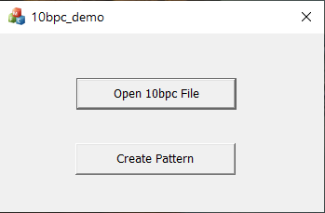

* + “Open 10bpc File” button

It loads and renders an image which includes 10bpc content, then 10bpc effect can be seen on the monitor which supports 10bpc.

You can get the image from <https://github.com/jursonovicst/gradient>.

* + “Create Pattern” button

It creates a grey scale image by HLSL. The image includes 8-bit and 10-bit content. Comparing the 8-bit and 10-bit content in the image, we can verify if the 10bpc effect is working.

# Acknowledgement

[1] This project is developed base on “Direct3D Game VS project templates” the github link https://github.com/walbourn/directx-vs-templates/tree/master/d3d11game_win32_dr